Pupil premium strategy statement – Mapplewell Primary School 2025 - 2028

This statement details our school’s use of pupil premium funding to help improve the attainment of our disadvantaged pupils.
It outlines our pupil premium strategy, how we intend to spend the funding in this academic year and the outcomes for disadvantaged pupils last academic year.

School overview
Detail | Data
Number of pupils in school | Mapplewell Primary
Proportion (%) of pupil premium eligible pupils | 340
Academic year/years that our current pupil premium strategy plan covers (3-year plans are recommended – you must still publish an updated statement each academic year) | 14% (51 pupils)  Deprivation 41  Service 3  LAC 3  Adopted from care 4
Date this statement was published | 2025 - 2028
Date on which it will be reviewed | September 2025
Statement authorised by | July 2026  July 2027  July 2028
Pupil premium lead | Gail Padfield
Governor / Trustee lead | Sam Garrood

Funding overview
Detail | Amount
Pupil premium funding allocation this academic year | £69,020
Pupil premium funding carried forward from previous years (enter £0 if not applicable) | £ 0
Total budget for this academic year  If your school is an academy in a trust that pools this funding, state the amount available to your school this academic year | £69,020

Part A: Pupil premium strategy plan

Statement of intent
At Mapplewell Primary School, we are committed to ensuring that every pupil, regardless of their background or individual challenges, is given the best possible chance to achieve their full potential. We recognise that high-quality teaching, targeted support, curriculum enrichment, and pastoral care are essential to closing the attainment gap between disadvantaged pupils and their peers.
Our Pupil Premium strategy is built on a whole-school approach underpinned by high expectations and evidence-informed practises that benefit all pupils, while providing focused, timely interventions where they are needed most. We believe that all pupils, including those from disadvantaged backgrounds, should have equal access to a broad, ambitious curriculum that enables them to succeed.
Our key aims through the Pupil Premium strategy are to:
- Improve the academic attainment and progress of disadvantaged pupils, ensuring they are well-prepared for the next stages of their education.
- Provide responsive, tailored support addressing individual needs across literacy, numeracy, behaviour, and wellbeing.
- Enhance pupils’ wider school experience by offering high-quality enrichment opportunities and developing cultural capital.
- Empower staff through high-quality professional development to identify and support disadvantaged pupils effectively.
- Engage families and the wider community as partners in supporting pupils’ learning and development.
Our approach is informed by rigorous analysis of internal and external data, ensuring that our actions are targeted, impactful, and regularly reviewed. We follow a clear, strategic, tiered model of provision aligned with EEF guidance:
- Whole-school strategies that promote positive outcomes for all pupils.
- Focused support targeting underperformance.
- Specific interventions designed to meet the unique needs of disadvantaged pupils.
We are dedicated to using Pupil Premium funding effectively to improve attainment, attendance, and wellbeing, ensuring that every child at Mapplewell Primary School leaves equipped with the knowledge, skills, and confidence to thrive, regardless of their starting point.

Challenges
This details the key challenges to achievement that we have identified among our disadvantaged pupils.
Challenge number | Detail of challenge
1 | On entry assessment to Early Years indicate underdeveloped oral language skills and vocabulary gaps in many disadvantaged pupils.  At baseline in September 2025, FS2 disadvantaged pupils were assessed at 50% to be on track for age related expectations for Speaking.  Non – Disadvantaged were assessed at 66% for Speaking.  Assessment indicates a greater need among this group to build a rich, broad vocabulary and deepen their comprehension of new language, which is vital for maximising their outcomes in reading, writing and overall communication throughout school.  Disadvantaged pupils do not attain in line with Non – Disadvantaged pupils to reach GLD by the end of EYFS.  Disadvantaged GLD for 2024/2025: 50%  Non – Disadvantaged GLD for 2024/2025: 67%
2 | Identification that on average disadvantaged pupils do not achieve as well as their peers in KS2 writing outcomes.  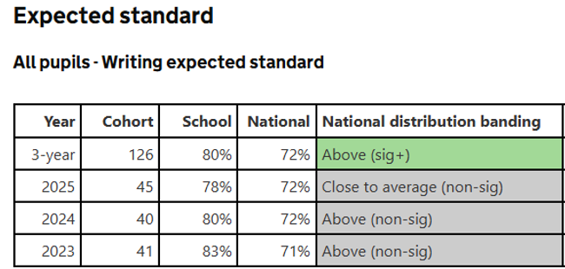  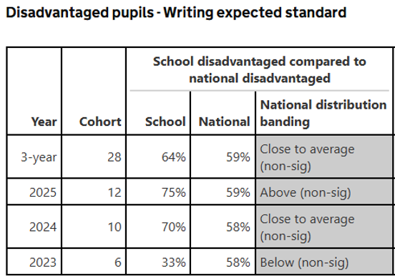  This Data highlights a significant opportunity to close the attainment gap for our disadvantaged pupils in KS2 writing outcomes. Data analysis shows a general trend that disadvantaged pupils at Mapplewell achieve above the national average, but do not achieve as well as Non – disadvantaged pupils.  Data analysis also identifies the gap
3 | Our attendance data indicates that attendance among disadvantaged pupils is lower than non-disadvantaged pupils, with PA being significantly higher.  Attendance data trends for previous 3 academic years (Sept 22 to Jul 25):  Disadvantaged pupils attendance for the academic year was 95.37%.  Non - Disadvantaged pupils attendance for the academic year was 95.58%.  10.26% of disadvantaged pupils have been ‘persistently absent’ compared to 8.68% of their peers during that period.  Our assessments and observations indicate that absenteeism is negatively impacting disadvantaged pupils’ progress.
4 | Our ongoing work with families has identified social and emotional issues for many pupils and their families, including a lack of enrichment opportunities. These challenges particularly affect disadvantaged pupils.  Data on engagement in clubs and shows an opportunity to increase participation among our disadvantaged pupils.

Intended outcomes
This explains the outcomes we are aiming for by the end of our current strategy plan, and how we will measure whether they have been achieved.
Intended outcome | Success criteria
Improved oral language skills and vocabulary among disadvantaged pupils. | Assessments and observations indicate significantly improved oral language among disadvantaged pupils. This is evident when triangulated with other sources of evidence, including engagement in lessons, book scrutiny and ongoing formative assessment.
Narrow the achievement gap between disadvantaged pupils and their peers by the end of their Early Years education. | Assessments will evidence an increase in the percentage of disadvantaged pupils attaining GLD at the end of EYFS2. The gap between this group of pupils and their peers will narrow.
Pupils to make rapid and sustained progress in writing. | Attainment for disadvantaged pupils continues on an upward trend for KS2 writing outcomes, narrowing he gap in comparison to all pupils.  Pupils leaving EYFS will have clear and measurable targets to implement in KS1 to ensure all pupils have foundational writing knowledge, ready to developed within KS2.  Internal data demonstrates that, in the main, disadvantaged pupils are on track to meet their writing target, narrowing the attainment gap between disadvantaged and non-disadvantaged pupils within the school.
To achieve and sustain improved attendance for all pupils particularly disadvantaged pupils. | Sustained high attendance by 2027 / 2028 demonstrates a decrease in the percentage of disadvantaged pupils who are persistently absent and an increase in overall attendance.
To achieve and sustain improved wellbeing for all pupils, particularly our disadvantaged pupils. | Sustained high levels of wellbeing by 2027 / 2028 demonstrated by:  - Qualitive data from pupil and parent/carer surveys, including feedback from families who have been supported through Early Help.  - An increase in pupil participation in enrichment activities, particularly among disadvantaged pupils.

Activity in this academic year
This details how we intend to spend our pupil premium funding this academic year to address the challenges listed above.

Teaching (for example, CPD, recruitment and retention)
Budgeted cost: £11,555
Activity | Evidence that supports this approach | Challenge number(s) addressed
Implement diagnostic assessments across school, including Wellcom, YARC, TTRS, RWI.  Training for staff to ensure assessments are interpreted and administered correctly. | When used effectively, diagnostic assessments can indicate areas for development for individual pupils, or across classes and year group.  Diagnostic assessment | EEF | 1, 2
Implement a robust oracy curriculum that supports language development across subjects in all phases of school.  CPD for staff on oracy and how to embed this effectively within all lessons. | When consistently implemented the average impact of an effective oracy curriculum for pupils is 6 months additional impact over the course of the year.  Oral language – Teaching and Learning Toolkit EEF | 1, 2
Consistently implement Numbersense across EYFS and KS1 to secure pupil’s early number sense and confidence in maths.  Fund maths lead release time to embed the key elements of number sense, ensure a systematic approach to the teaching of early mathematics and review the impact on pupil achievement. | Having a deep and secure understanding of number lays the firm foundations that sets children up for success later on.  Improving Mathematics in Early Years and Key Stage 1 Guidance Report EEF | 1
Consistent approach to the teaching of literacy that encompasses the firm foundations required to become a fluent and confident writer.  CPD on handwriting, spelling and writing, linked to the new DfE Writing Framework.  New pencil grip and handwriting assessment tools to be implemented for all staff. | Teaching staff to have a robust assessment system allows for targeted support for pupils who do not foundational skills for writing.  EEF – Helping Handwriting Shine | 2

Targeted academic support (for example, tutoring, one-to-one support, structured interventions)
Budgeted cost: £24,442
Activity | Evidence that supports this approach | Challenge number(s) addressed
One to one and small group additional support delivered in addition to and linked with normal lessons.  Regular review points to measure the impact of intervention. | Targeted support at specific needs and knowledge gaps can be an effective method to support low attaining pupils or those falling behind.  One to one tuition | Teaching and Learning Toolkit | EEF  Small group tuition Teaching and Learning Toolkit EEF | 1, 2,
Implement bespoke SALT packages to best support individual speech and language development.  CPD to best support the SALT TEAACH Champion. | Oral language interventions can be an effective approach for disadvantaged pupils.  Oral Language Interventions EEF | 1,

Wider strategies (for example, related to attendance, behaviour, wellbeing)
Budgeted cost: £33,023
Activity | Evidence that supports this approach | Challenge number(s) addressed
Embed the principles of good practice set out in the DfE’s guidance on working together to improve school attendance.  Train staff and develop and implement new approaches to improving attendance.  Targeted support and intervention conducted by the school’s learning mentor to fully engage key families in understanding the importance of regular attendance. | The DfE guidance has been informed by engagement with schools that have significantly reduced levels of absence and persistent absence.  Working Together to Improve School Attendance | 3
Embed a culture that promotes SEMH and pupil wellbeing.  Revise the Personal Development offer to incorporate the school’s vision, values and wider offer. Ensure this is understood and promoted by all stakeholders. | There is extensive evidence associating childhood social and emotional skills with improved outcomes at school and in later life.  Improving Social and Emotional Learning in Primary Schools EEF | 4
Implement robust SEMH interventions to best support identified pupils.  Early identification of pupil need alongside parent partnership will be utilised to identify key pupils in need. Regular assessments to evaluate impact and progress. | Implementing SEMH interventions is a crucial aspect of supporting pupils with SEMH needs. These interventions aim to provide tailored support to help pupils cope with their emotions, build resilience and develop coping strategies. By implementing these interventions educators create a supportive environment that foster wellbeing and enables pupils to engage more fully in their learning.  Understanding the Impact of SEMH Needs on Learning | 4
Establish an extra-curricular offer that clear links with the school’s personal development vision.  Survey pupils and parent/carer to gather their views on their interests and the impact of this offer.  Continually gather data of disadvantaged uptake of clubs every half term, so that pupils can be encouraged to raise participation levels of disadvantaged pupils. | Research suggests that disadvantaged pupils require access to a variety of extra-curricular activities to develop essential skills and social networks.  An Unequal Playing Field: Extra-curricular activities, soft skills and social mobility – GOV.UK | 4
Carefully planned projects and work completed by the learning mentor, to best support the development of the social and emotional needs of key families.  Review the current pastoral offer to enhance positive home-school relationships. | More intensive approaches, which target particular families or outcomes, are associated with larger learning gains.  Working with Parents to Support Children’s Learning EEF | 4

Total budgeted cost: £ [insert sum of 3 amounts stated above]

Part B: Review of the previous academic year

Outcomes for disadvantaged pupils

Externally provided programmes
Please include the names of any non-DfE programmes that you used your pupil premium to fund in the previous academic year.
Programme | Provider
Read, Write Inc | Ruth Miskin
Times Tables Rock Stars | Maths Circle
NumBots | Maths Circle
Wellcom | Wellcom
YARC | GL Assessment

