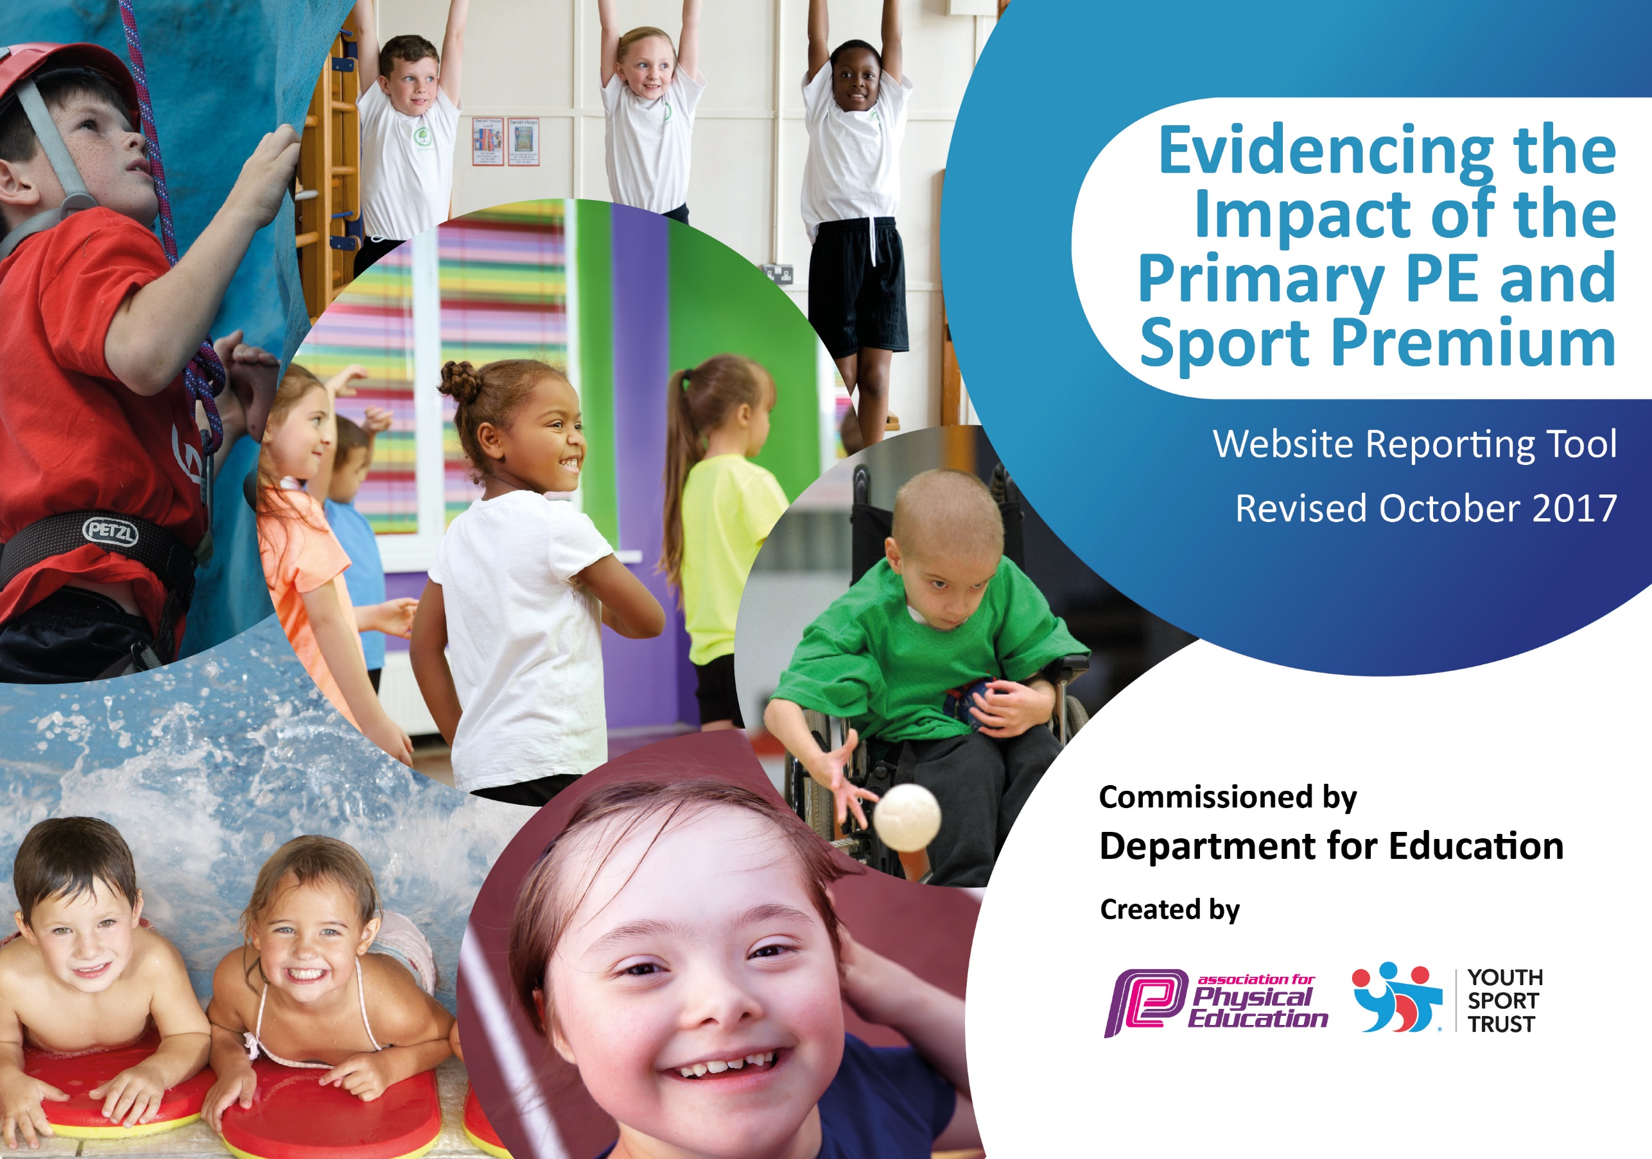

Mapplewell Primary School 2023-2024

At Mapplewell Primary School we firmly believe that sustainable improvements to the quality of PE and sport is fundamental to developing outcomes for our pupils. We aim to use the Primary PE and Sport Premium to:

- develop or add to the PE and sport activities that your school already offers
- build capacity and capability within the school to ensure that improvements made now will benefit pupils joining the school in future years

We welcome the Sports Premium Grant to provide additional funding to improve provision of PE and sport in our school. The key areas for consideration are; Physical Education, Healthy Active Lifestyle Choices and Competitive Sports.

Current achievement and priorities

Key achievements to date: | Areas for further improvement and baseline evidence of need:
- Children are able to take part in a wide range of sporting clubs (3 different sports afterschool clubs were carried out on a weekly basis in 2022-23).  - Children regularly participate in competitive sports through the school’s partnership with PSP.  - KS2 children participated in Sports Day at Dorothy Hyman Sports Arena to experience spot in an elite setting.  - Children are given the opportunity in upper KS2 to take part in residential.  - Mapplewell has implemented the use of INSIGHTS as an assessment in order to sport gaps in learning and inform next steps. | - PE lead to continue to develop the PE long-term plan to ensure there is a clear progression of skills between Key Stages.  - Continue to track individual children that are accessing extra-curricular activities in order to get a whole school picture as to the percentage of children benefitting from the work of the sports coordinator. Record to be kept of % of PP children able to access additional activities.  - Mapplewell entered 100% of PSP sports events. For the academic year of 2023-24, a minimum of 75% of events shall be entered.  - Mapplewell children to be given the opportunity to watch live sport in an elite setting (once a term).

Meeting national curriculum requirements for swimming and water safety | Please complete all of the below:
What percentage of your Year 6 pupils could swim competently, confidently and proficiently over a distance of at least 25 metres when they left your primary school at the end of last academic year? | 86%
What percentage of your Year 6 pupils could use a range of strokes effectively [for example, front crawl, backstroke and breaststroke] when they left your primary school at the end of last academic year? | 62%
What percentage of your Year 6 pupils could perform safe self-rescue in different water-based situations when they left your primary school at the end of last academic year? | 62%
Schools can choose to use the Primary PE and Sport Premium to provide additional provision for swimming but this must be for activity over and above the national curriculum requirements. Have you used it in this way? | No

Action Plan and Budget Tracking

Academic Year: 2022/23 | Total fund allocated: £18,000 | Date Updated: September 2022
Key indicator 1: The engagement of all pupils in regular physical activity – Chief Medical Officer guidelines recommend that primary school children undertake at least 30 minutes of physical activity a day in school |  |  |  | Percentage of total allocation:
 |  |  |  | 0%
School focus with clarity on intended impact on pupils: | Actions to achieve: | Funding allocated: | Evidence and impact: | Sustainability and suggested next steps:
More frequent inter school and intra school events. An increase in school competitive sports.  Children’s engagement in sports can be tracked throughout school (sports spreadsheet)  Children are able to access a range of activities additional to the requirements of the curriculum and these are accessed through after school clubs and high quality external providers.  Low cost additional sporting events allows accessibility for all pupils particularly beneficial for those from disadvantaged backgrounds. | Afterschool sports clubs provided by  school staff (3 x 1 hour per week)  Inter/Intra sports  Links with other schools  Sports coordinator to continue to create clear tracking system in place to monitor which children are accessing additional sporting activities. Record to be kept of % of PP children able to access additional activities. | £0
Key indicator 2: The profile of PE and sport being raised across the school as a tool for whole school improvement |  |  |  | Percentage of total allocation:
 |  |  |  | 46%
School focus with clarity on intended impact on pupils: | Actions to achieve: | Funding allocated: | Evidence and impact: | Sustainability and suggested next steps:
Children experience sport participation in and elite and extremely inspiring environment.  Children to be able to understand rules and character of competitive sports.  Better provision and resources to deliver high quality teaching. Will also impact on the quality of intra/inter school activities that can be delivered.  PE curriculum with clear focus on the progression of skills.  Increase the profile of PE in school through the use of Twitter. | Audit of PE equipment carried out and new equipment ordered.  New equipment to be purchased throughout the year as necessary.  Hiring of Dorothy Hyman Stadium for KS2 Sports Day.  Intra-school sports tournaments.  PE coordinator to develop a clear overview of the delivery of the PE curriculum, implementing the progression of skills from the HCAT trackers.  Elite athlete to visit school to inspire children (potentially Sheffield Sharks).  Twitter page set up to celebrate QFT of PE and children accessing extra-curricular activities. | Equipment –  £4,000  EYFS Equipment - £4,000  KS2 Sports Day & Transport - £250

Key indicator 3: Increased confidence, knowledge and skills of all staff in teaching PE and sport |  |  |  | Percentage of total allocation:
 |  |  |  | 0%
School focus with clarity on intended  impact on pupils: | Actions to achieve: | Funding  allocated: | Evidence and impact: | Sustainability and suggested  next steps:
Teachers to teach high quality lessons which teach progression of skills in a range of sports.  Assessment and monitoring of PE is effective. | PE coordinator to continue to develop a clear overview of the delivery of the PE curriculum, implementing the progression of skills from the HCAT trackers.  Teachers to have access to The PE Hub scheme of work, to support the delivery of lessons  PE coordinator to continue conduct staff meetings to upskill teachers and develop confidence to deliver PE lessons which incorporates the Accelerated Learning Cycle.  Teaching staff to continue to use INSIGHTS to assess and HCAT planning documents to plan for progression within each sport. | £0
Key indicator 4: Broader experience of a range of sports and activities offered to all pupils |  |  |  | Percentage of total allocation:
 |  |  |  | 17%
School focus with clarity on intended  impact on pupils: | Actions to achieve: | Funding  allocated: | Evidence and impact: | Sustainability and suggested  next steps:
Increased safety and confidence of children using bicycles both on and off road.  Year 4 pupils access swimming lessons.  Year 6 children to attend Soar Trampoline Park as an end of year celebration.  Increase the opportunities to watch live sport in an elite setting. | EYFS children to participate in balance bikeability sessions.  Year 5 children to participate in bikeability sessions.  School to purchase bikes & safety equipment for children without them.  Children given the opportunity to attend a live sports event in an elite setting (termly) | Balance Bikeabilty - £80  Bikeability - £1,000  Trips to elite sports events - £2,000
Key indicator 5: Increased participation in competitive sport |  |  |  | Percentage of total allocation:
 |  |  |  | 36%
School focus with clarity on intended  impact on pupils: | Actions to achieve: | Funding  allocated: | Evidence and impact: | Sustainability and suggested  next steps:
A wide variety of competitive sports should be covered over the year to add breadth of study and to identify children that are gifted in significant areas.  Children at both KS1 and KS2 should have the opportunity to take part in competitive sports.  Children to be able to experience sport out of the usual school environment. | School to be a part of Pro-Active School Performance competitions.  Sports coordinator to identify links with other schools – HCAT sports calendar.  Football pitch to be marked out and regularly cut.  Transport for sporting events.  Supply teachers to be hired to release sports coordinator from class to attend sports events.  Trophies and medals to be purchased to celebrate intra-school competitions | PSP - £1,000  Upkeep of Football Pitch –  Transport – £5,000  Supply Teachers –  Trophies & Medals - £450

